Goals, objectives and metrics for the TB4 evaluation method
Area | Goal | Objectives | Metrics | What to evaluate and how | Relevant TB Scenarios and other comments
PT | Scalability | Improve performance, throughput, or storage capacity by increasing the number of nodes in the Platform | Speedup  Efficiency  Throughput | - Speedup(p)=Time(1)/Time(p)  p…number of nodes  - Efficiency(p)=Sp/p  - Scaleup(p)=Workload(1)/Workload(p) | For a given workflow, the number of nodes and/or the payload data is gradually increased
 | Robustness | Evaluate the reliability of the system in case of heavy load, hw/sw failure, malicious users | Number of use-cases tested, impact on the system and/or application run. | - Has the system managed to cope with a given test (e.g. a long running workflow)?  - Were failures detected (check log files and sanity check results)?  - How severe was the impact on the system/application (did the application recover, can it be restarted, did it crash the entire platform) | Test workflows with different tools, number of input files, size of input files, …
 | Integration | Evaluate to which extend the platform can be integrated with a given TB environment | Data Integration  Tool Integration  Repository Integration | - Would it be possible to incorporate the Platform with the institutional data holdings (e.g. data is fetched on demand, expensive storage migration required, not possible at all)?  - Possible to integrate the required tools/workflows with the Platform (e.g. yes, required lots of manual intervention, would require to call a remote web services, not possible at all)  - To which extent is repository integration possible (e.g. can connect PT to institutional repository system, can use PT’s repository reference implementation, can adapt local system to integrate with PT, not possible/required at all) | Evaluate different Testbeds and institutional settings
 | Cost | In a production environment, it is usually required to operate a Platform instance locally at the institution. Evaluate if this is affordable | Cost for hardware  Cost for hosting  Cost for maintenance  Cost for integrating with existing infrastructure | - Evaluate to which extent a private Platform instance would be beneficial for a given institution/Testbed (e.g. only for the web archive, only for calculating statistical data, possible to migrate entire holdings on PT storage, …) | Evaluate different Testbeds and institutional settings
 | More?
PC AC | Usability / Operability | Measure the degree to which a product or system has attributes that make it easy to operate and control.  We want to know how much we have improved the tools in terms of making them easy to use by preservation practitioners. | Success rate and average time of using the tool for common and pre-defined operations. | Survey users to subjective evaluate the tools according to how difficult they perceived the use of the tool to be.  Objectively measure the average time a group of users take to learn and complete a series of migration challenges.
 | Performance efficiency / time behaviour | Improve performance, and throughput by making sure that tools run on a cluster environment and increasing the number of nodes makes the tools scale | Speedup, Efficiency, Throughput | Speedup(p)=Time(1)/Time(p)  Efficiency(p)= Time(1)/(p * Time(p))  Throughput(p)=(Input Size + Output Size) / Time(p)  p = number of nodes | We know that is platform dependent, however, we are not sure that we will improve vertical scalability of any tool, only horizontal scalability, and that depends of the environment. Focus will be on making sure that the tool runs correctly on the cluster.
 | Reliability / Fault tolerance | Improve the degree to which a tool operates as intended despite the presence of issues in its inputs and environment. | Tools make a good use of error codes and generate the appropriate error code for a given issue | Test the tools with input issues:  - wrong formats  - corrupted files  - wrong parameters  - IO errors (read permissions, unexisting file, socket closed, write permissions, disk full) | Is this correctness?
 | Portability / installability | Increase the degree of effectiveness and efficiency with which a tool can be successfully installed and/or uninstalled in a specified environment | How easy is the tool to install, e.g.:  - Tool needs to be compiled  - Tool is available on app stores or package repositories  - Tool has a lot of dependencies | Classification of each tool according to how easy they are to install. Give a score such as Low, Medium, High on how easy a tool is to install.
 | Compatibility / interoperablity | Increase the degree to which two or more systems, products or components can exchange information and use the information that has been exchanged | Can the tool be invoked from more than one operating system | Yes – if the tool runs or can be invoked on multiple platforms  No – if the tool cannot be run or invoked from different platforms. | This has mainly to do with the fact that we will wrap the tools in Web services making them invokable from more systems.
The below is the originally defined goals/objectives... for PA (by Christoph Becker)
 | Scalability | Substantially improve scalability of certain preservation action tools in terms of scalability (time, memory, capacity) | ISO 250x0 Performance efficiency:  Resource utilization, time behaviour, capacity  (of components, measured per object, cf. D14.1) | - The evaluation workflow is part of Plato, which ensures comparability, standard specification, full documentation etc  - The evaluation criteria are specified in the objective tree in Plato  - The criteria model is developed in PW, aligned with ISO SQUARE  - Automated measurement of timing and resource usage should happen within Taverna workflow / in PT execution environment  - Measurements of correctness are taken mostly by QA tools within Taverna workflows, and some manual evaluation documented in Plato  - Assessment of results is part of planning  - Summative and/or large-scale results are published in REPEL The deployment on the platform for scalability is an evaluation separate from the component-level experiments | Using systematic evaluation of actions in TB scenarios following the Plato approach, we can point to the gaps that should be addressed, thus providing a baseline assessment.  After addressing these gaps, we add the new or improved actions to the existing case assessment and show directly the quantitative improvement in comparison to the baseline and whether this is sufficient to “solve” the corresponding TB scenario.
 | Correctness and Reliability | Substantially improve reliability / correctness of a number of action components (areas selected based on TB needs) | Functional correctness:  Valid and well-formed objects containing the exact same content (e.g.: containing undistinguishable images with lossy compression...)
 | Robustness | Fault tolerance | Ability of components to cope with invalid input...
 | Reusability | Discoverability,  Availability: Make components invokable | Number of tools registered in components catalogue as  queried in Watch and Planning and/or referenced by REPEL experiments | Watch component statistics will improve over time and could be published regularly: These capture the amount of components available for certain tasks as well as some of their properties
PC  CC | Functional suitability – functional completeness: Identification | Identify >x% of web archive content objects, giving at least the mimetype | % of files reported unknown ... | Taverna workflows  Content profiler  Results published in REPEL | Statistics should be published
 | Functional suitability – Functional Correctness | Correctly Identify >x% of web archive content objects on average | % of files correctly identified | Taverna workflows  Validation against test data set with known ground truth | Content profiler  LSDR, Web archive
 | Functional suitability – functional completeness: Characterisation | Deliver full characteristics for set of objects | Coverage of properties (in %) that are specified in the content profile as mandatory and can be delivered by CC | Taverna workflows,  Results published in REF (so they can be monitored by Watch),  Watch component statistics over time
 | Scalability | Performance (see above) | (see above) | ...
 | Sustainability | A tool needs to be sustainable – e.g. have a community, be released as proper open source, been taken up by an organisation to lead the maintainance. |  | Hard to evaluate ? | If a certain tool is used by only a small fraction of the DP community or the entire World, then it might vanish or become obsolete. So, even though a tool is technically very adept, it might not be the best choice if nobody use it.
PC  QA | Functional suitability – functional completeness | Provide full coverage of all measures required to validate conversion of TIFF to JP2 lossy | % of metrics measured automatically  (as percentage of planning decision criteria)  If infeasible: % of metrics having rejection potential that can be measured automatically (cf. D14.1) | The TB scenarios determine which criteria have to be measured in migration processes as part of the Plato workflow, using the Plato criteria model to specify significant properties ( in a controlled vocabulary)  Taverna workflows then deliver measures for criteria, the results are published in REPEL.  Watch component monitors progress in terms of % of criteria that can be measured, in terms of QA components that can measure criteria, etc. | A number of TB scenarios require QA to be carried out to verify the correctness of migration actions. Using Plato to specify the objective tree and the standardised vocabulary to specify them, we can quantify to which degree automated QA tools can cover the significant properties that need to be verified, and can quantify the amount of manual effort required to validate migration processes.  We can even quantify through Watch the progressive coverage of QA tools on significant properties, and how many organisations have run experiments (through Watch and REPEL)
 | Functional suitability – functional correctness | Provide correct assessment of similarity between images | % of metrics that are correct  For lossy JP2: correlation of metrics delivered with human subjective assessment
 |  | Provide correct assessment of similarity between audio files | % of metrics measured automatically  (as percentage of planning decision criteria)  If infeasible: % of metrics having rejection potential that can be measured automatically
 |  | Provide correct assessment of similarity between web pages | % of metrics measured automatically  (as percentage of planning decision criteria)  If infeasible: % of metrics having rejection potential that can be measured automatically
 |  | Provide correct assessment of similarity between office documents | % of metrics measured automatically  (as percentage of planning decision criteria)  If infeasible: % of metrics having rejection potential that can be measured automatically
PP | Maturity | Improve maturity of planning process: “move from ad-hoc decision making to integrated, continuously optimizing management process” | Process maturity of planning  - Awareness and Communication  - Policies, Plans and Procedures  - Tools and Automation  - Skills and Expertise  - Responsibility and Accountability  - Goal Setting and Measurement | A maturity model for Preservation Planning exists, Cf. Article at ASIST-AM 2011. Criteria for each dimension specify what has to be present for each maturity level (0-5) to be achieved.  For example:  - Are quantified measures linked to objectives and business goals?  - Is the responsibility and accountability for planning decisions clearly specified and communicated?  - Are the skills and expertise requirements for each role clearly documented?  - Is the assessment of drivers and constraints quantified, documented and standardised?  - Is information continuously and consistently delivered to planning and is it acted upon? | Conduct a capability assessment, best as a case study.  Formal policies should contribute substantially to the improvement of maturity
 | Scalability | Improve decision making efficiency | Effort required to create one plan  Number of plans required to cover certain amount of content  Number of interactions points required for creating/updating a (trustworthy!) plan; number of evaluation steps required; time passing between creating a plan and approving it; time spent in Plato between creating a plan and approving it  (many more in ASIST 2011) | Case studies in planning: baseline comparison, user studies. Plato 4 will have an ability to trace user behaviour so we can quantify how much effort is spent in which aspects of planning  (this is really testing the ability to scale in diversity/heterogeneity)  (these are more objective metrics and easier to collect than “effort”)  (e.g. if alternatives can be progressively filtered, the number of values that have be entered can be reduced drastically. We should quantify this) | A number of TB scenarios have evaluation and planning problems in them.  When we conduct planning studies in order to evaluate action components, we can at the same time conduct baseline measures that quantify the efforts spent on planning. Then we can analyse where improvement is most urgently needed (e.g. is it in requirements specification or in evaluation or in selecting candidates?).
 | Lifecycle support | Improve ability to update plans with traceability | Include lifecycle support in plans and operations | - Is it possible to update plans, i.e. create new revisions of plans, linking them to previous versions?  - Can new revisions of plans be automatically deployed so that old revisions are decommissioned and it is clear which plan is currently active?
 | Organisational fit | Enable systems integration  Improve process flexibility and integration | Integration with repositories and the SCAPE platform  Integration with monitoring  Ability of processes (planning, policies, watch) to be leveraged in organisations | - Are there cases of successful integration? (demonstrations)  - Are there any API specifications? Are they completely covering the integration features required?  - Are there TCKs to test and verify compatibility automatically?  - Are there reference implementations of these TCKs?  - Are there best-practice reports of how to integrate planning, watch and policies processes in an organisation? | Conduct systems analysis and case studies, provide demonstrations and reference implementation, practice reports
 | Context awareness | Enable semantic context awareness | Existence and integration of policy model | - Which are the primary drivers and constraints?  - Are the key drivers and constraints covered by formal descriptions (policy model)?  - Are these specifications used in planning and watch systems? | The TB scenarios are of course packed with context.  Case studies and practice reports should discuss how this context is fed into planning and operations
PW | Completeness | Ensure the watch component solves the real-world problems | Coverage of diverse scenarios (content types, access paths, complexity) in terms of:  - Properties required by questions that can be gathered automatically  - Properties defined by sources that can be correctly represented in data model  - Question that can be formalized in the Watch query language | Using case study scenarios, we can show very specifically how the watch component can be used to solve relevant real cases.
 | Functional correctness | Ensure the watch component gives correct information about the world. | Number of false-positives and false-negatives. | Using a simulation of the environment, test the ability of the system to correctly monitor the system and answer to questions, gathering false-positives and false-negatives. | Its important to point out that the watch component will be as accurately as the information it holds. What we are testing is the ability of providing the right answer to a question based on the facts that the component knows about, i.e. based on the assumption that the collected facts about the world are true and correct.

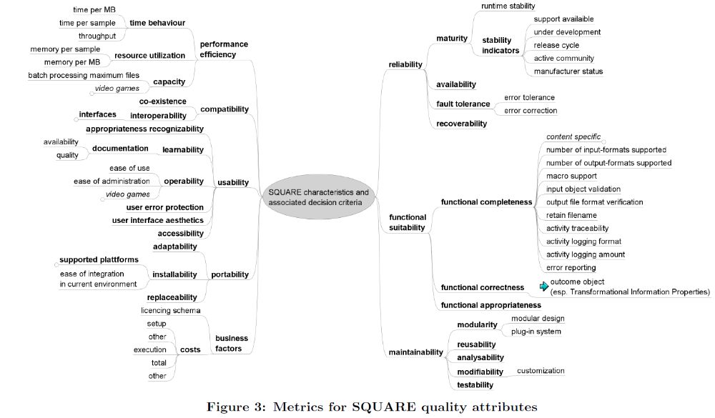
Figure 1 Metrics from (Hamm, IPRES 2011)

